EE 231
Spring 1998
An Improved Signed Array Multiplier

Drs. Absher and Williams:
This is much better, since it uses Dr. Absher’s idea.

Ned Lecky
2/10/98

Basic Design
This is an improved signed, 2’s-complement array multiplier. The concept is very clever, and seems like it should be taught or discussed more. I found no hint of this in any of my digital design texts. In fact, the Roth VHDL text makes reference only to the complementing type circuit I originally proposed, (see p. 132) whose diagram is repeated below.
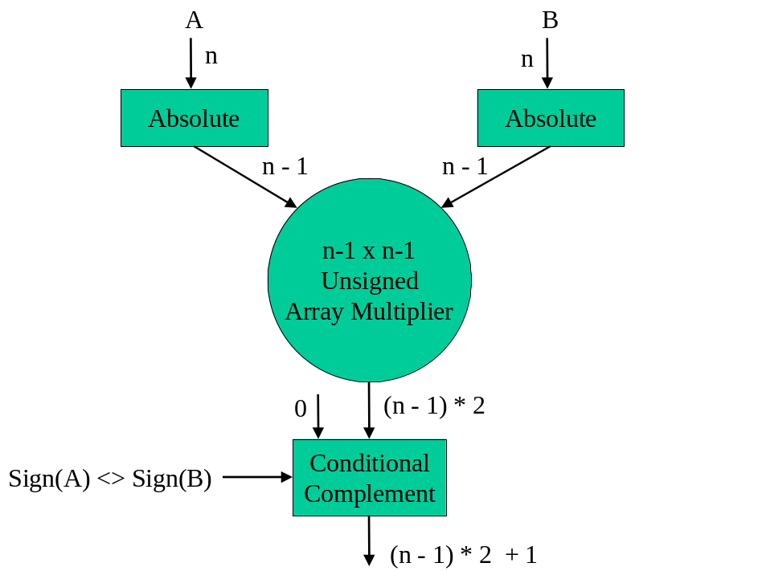
In retrospect, this turns out to be a terrible implementation. The key is in realizing that 2’s-complement numbers have only one sign bit, and then following the logic from there. This treatment owes much thanks to Dr. Absher, without whose hints this would never have been attempted.
An n-bit 2’s-complement number should be thought of as a set of bits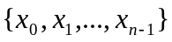defining a quantity as follows:
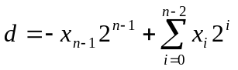
Thought of this way, the 2’s-complement number 11011 is really –16 + 11, or –5. The key is in realizing that through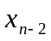may be treated as positive, unsigned bits.
A traditional array multiplication may then be represented (using 4-bit operands for illustration) as:
-0 0 0 0
x -0 0 0 0
-----------
-0 0 0 0 row 0
-0 0 0 0 row 1
-0 0 0 0 row 2
0 -0 -0 –0 row 3
--------------------
where “-0” represents negative bits, and “0” represents positive bits.
The four intermediate multiplication rows are developed in the standard way using AND gates, since 1 times 1 is 1, and anything times 0 is 0. The first addition is between the row 0 and 1 outputs of the AND array. The LSB of row 0 propagates directly to the result, and the remaining bits are added as follows:

-0 0 0 0 row 0
-0 0 0 0 row 1

Trouble!

The rightmost addition (ignoring the propagated LSB of row 0) is a standard Half-Adder (HA). The next addition is a standard Full-Adder (FA). The third addition is the sum of a negative bit, a positive bit, and a positive input carry. This set of inputs can sum to –1, 0, 1, or 2, which is a problem that needs to be fixed.
Consider that if the carry out is redefined as a borrow, giving it negative weight, and the sum is kept positive, the following sum,carry outputs are possible:
0,0 -0 + 0 = 0
0,1 -0 + 1 = 1
1,0 -2 + 0 = -2
1,1 -2 + 1 = -1
This gives a “signed” full adder with an output range of –2 to 1 inclusive. This does not match the requirements in the “Trouble” column.
However, if row 0 is simply signed extended, duplicating its MSB to create a new MSB, we have a new scenario:

-0 0 0 0 0 row 0
-0 0 0 0 row 1

Now, the problem column just needs a standard FA, and the most significant column is adding two negative bits and a positive input carry, which require a range of –2 to 1.
The –2 to 1 range FA we can call Full-Adder Minus,Minus,Plus (FAMMP), which is described by the truth table below.

FAMMP
-A | -B | Cin |  |  | Sum |  | -Cout
0 | 0 | 0 |  |  | 0 |  | 0
0 | 0 | 1 |  |  | 1 |  | 0
0 | 1 | 0 |  |  | 1 |  | 1
0 | 1 | 1 |  |  | 0 |  | 0
1 | 0 | 0 |  |  | 1 |  | 1
1 | 0 | 1 |  |  | 0 |  | 0
1 | 1 | 0 |  |  | 0 |  | 1
1 | 1 | 1 |  |  | 1 |  | 1
After adding AND array rows 0 and 1, it is time to turn attention to the subsequent additions. These next row additions turn out to be identical to the row 0/row1 addition, with the exception that the addition is now performed between a new AND array output row and the previous sum.
Adding row 2 into the row 0/row 1 sum looks like:

-0 0 0 0 0 row 0/row 1 sum
-0 0 0 0 row 2

This is because the row 0/row 1 sum has five bits already due to the final carry out of the most significant add in the previous addition. Here, no sign extension is therefore required. Thus the same hardware structure (from LSB to MSB: HA, FA, FA,…,FA, FAMMP) is indicated.
The last addition is special, since more negative bits lie in the last AND array row. This multiplication looks like:

-0 0 0 0 0 sum n-2
0 -0 -0 -0 row n-1

This addition must start at the LSB (again, ignoring the dropped LSB of sum n-2) with a Half-Adder Minus,Plus (HAMP) whose outputs can be –1, 0 or 1. Thus, we can define the carry out as being negative, and develop the following HAMP truth table.

HAMP
-A | B | Sum |  |  | -Cout
0 | 0 | 0 |  |  | 0
0 | 1 | 1 |  |  | 0
1 | 0 | 1 |  |  | 1
1 | 1 | 0 |  |  | 0
Since all subsequent more-significant bits will receive a negative carry in, the FAMMP will work at every stage as long as the negative bits are connected to its two negative inputs.

Design Verification in C
The design proposed here is theoretically aggressive enough to be worthy of suspicion. For this reason, a C simulation was developed to fully simulate the hardware.
A special effort was made to create a BitVector class and VHDL-like components which could be placed into the simulation in a manner identical to the eventual VHDL implementation. The technique used here would be easily applied to other digital designs, and offers the advantage of providing a complete C/C++ support structure in which to generate tests, analyze results, generate specialized output, and so on. The simulator code is shown below, and includes both the new signed multiplier design and a traditional unsigned multiplier design.

// Signed and Unsigned Array Multiplier Simulation
// John E. Lecky
// 2/10/98

// This is a C++ simulator for hardware array multipliers taking signed and
// unsigned inputs. The simulation is written to be a hardware simulator, not
// not a behavioral simulator.

// SUPPORT
#include <stdio.h>
#include <memory.h>
#include <string.h>
#include <conio.h>
#include <math.h>
#include <stdlib.h>

// BASIC DEFINES
typedef int BOOL;
typedef int bit;
#define TRUE -1
#define FALSE 0
#define SIGNED 1
#define UNSIGNED 0
struct AdderOut
{
bit sum;
bit carry;
};

// This is the BitVector class which represents arbitrary width signals
// It is designed to be aware of the signed or unsigned nature of the signal
class BitVector
{
private:
bit fSigned;
int len;
bit* bits;
char* printBuf;
public:
BitVector();
BitVector(int i,int n,int s);
~BitVector();
void Set(int i,int n,int s);
int Integer(void);
char* Show(BOOL fConvertToo=1);
bit& operator[](int i);
int Len(void) {return len;}
bit Signed(void) {return fSigned;}
};

// BASIC GATES
void AND(bit a,bit b,bit& y);

// ADDER BLOCK PROTOTYPES
void FA(bit a,bit b,bit c,bit& sum,bit& carry); // standard FA
void FAMMP(bit a,bit b,bit c,bit& sum,bit& carry); // FA with first 2 inputs considered negative
void HA(bit a,bit b,bit& sum,bit& carry); // Standard HA
void HAMP(bit a,bit b,bit& sum,bit& carry); // HA with first input considered negative

// MULTIPLIER PROTOTYPES
int SignedArrayMultiply(BitVector& m0,BitVector& m1);
int UnsignedArrayMultiply(BitVector& m0,BitVector& m1);

// TEST VECTOR DEFINITION
struct TestVector
{
int opr1; // operand 1
int opr2; // operand 2
int len; // operand length in bits
int fSigned; // signed or unsigned data
int result; // expected result
};

int main()
{
// setup parameters
const int width=8;
const int nTests=128;

// create random test vectors
int powN=(int)pow(2,width);
int powNm1=(int)pow(2,width-1);
int mask=powN-1;
TestVector* tv=new TestVector[nTests];
for(int i=0; i<nTests; i++)
{
tv[i].len=width;
tv[i].opr1=rand()&mask;
tv[i].opr2=rand()&mask;
tv[i].fSigned=rand()&1; // 50% signed; offset if signed
if(tv[i].fSigned)
{
tv[i].opr1-=powNm1;
tv[i].opr2-=powNm1;
}
tv[i].result=tv[i].opr1*tv[i].opr2; // expected result
}

// apply test vectors
int nPass=0;
int nFail=0;
for(i=0; i<nTests; i++)
{
BitVector m0;
BitVector m1;
m0.Set(tv[i].opr1,tv[i].len,tv[i].fSigned);
m1.Set(tv[i].opr2,tv[i].len,tv[i].fSigned);
int ret;
if(tv[i].fSigned)
ret=SignedArrayMultiply(m0,m1);
else
ret=UnsignedArrayMultiply(m0,m1);
if(ret==tv[i].result)
{
printf("PASS\n");
nPass++;
}
else
{
printf("FAIL expected %d got %d\n",tv[i].result,ret);
nFail++;
getch(); // pause on failure
}
}

printf("PASSES: %d FAILS: %d\n",nPass,nFail);
return 0;
}

// UNSIGNED ARRAY MULTIPLY
int UnsignedArrayMultiply(BitVector& m0,BitVector& m1)
{
int width=m0.Len();

printf("Unsigned Multiplier Simulation\n");
printf("%*s%s\nx\n%*s%s\n",width+2,"",m0.Show(),width+2,"",m1.Show());
for(int i=0; i<width*2+2; i++)
printf("=");
printf("\n");

if(m0.Len()!=m1.Len())
{
printf("ERROR: Length Mismatch\n");
return 0;
}

// setup intermediate signal vectors
BitVector* ands=new BitVector[width];
BitVector* sums=new BitVector[width-1];
BitVector* carries=new BitVector[width-1];
BitVector result;

// size and initialize intermediate signals
for(i=0; i<width; i++)
ands[i].Set(0,width,UNSIGNED);
for(i=0; i<width-1; i++)
{
sums[i].Set(0,width+1,UNSIGNED);
carries[i].Set(0,width,UNSIGNED);
}
result.Set(0,width*2,UNSIGNED);

// compute AND tree
for(i=0; i<=width-1; i++)
for(int j=0; j<width; j++)
AND(m0[j],m1[i],ands[i][j]);

// first sum row
HA(ands[0][1],ands[1][0],
sums[0][0],carries[0][0]);
for(int j=1; j<=width-2; j++)
FA(ands[0][j+1],ands[1][j],carries[0][j-1],
sums[0][j],carries[0][j]);
HA(ands[1][width-1],carries[0][width-2],
sums[0][width-1],sums[0][width]);

// rest of the sum rows
for(i=1; i<=width-2; i++)
{
HA(sums[i-1][1],ands[i+1][0],
sums[i][0],carries[i][0]);
for(int j=1; j<=width-1; j++)
FA(sums[i-1][j+1],ands[i+1][j],carries[i][j-1],
sums[i][j],carries[i][j]);
sums[i][width]=carries[i][width-1]; // drop carry into bit n of the sum
}

// pull result bits down
result[0]=ands[0][0];
for(i=1; i<=width-2; i++)
result[i]=sums[i-1][0];
for(i=0; i<=width; i++)
result[i+width-1]=sums[width-2][i];

// show AND tree
printf("AND ARRAY\n");
for(i=0; i<width; i++)
printf("%*s%s\n",width+2-i," ",ands[i].Show(FALSE));

// show sums
printf("PIPELINED SUMS\n");
for(i=0; i<width-1; i++)
printf("%*s%s\n",width-i," ",sums[i].Show(FALSE));

// show result
printf("RESULT\n");
printf(" %s\n",result.Show());

return result.Integer();
}

// SIGNED ARRAY MULTIPLY
int SignedArrayMultiply(BitVector& m0,BitVector& m1)
{
int width=m0.Len();

printf("Signed Multiplier Simulation\n");
printf("%*s%s\nx\n%*s%s\n",width+2,"",m0.Show(),width+2,"",m1.Show());
for(int i=0; i<width*2+2; i++)
printf("=");
printf("\n");

if(m0.Len()!=m1.Len())
{
printf("ERROR: Length Mismatch\n");
return 0;
}

// setup intermediate signal vectors
BitVector* ands=new BitVector[width];
BitVector* sums=new BitVector[width-1];
BitVector* carries=new BitVector[width-1];
BitVector result;

// size and initialize intermediate signals
for(i=0; i<width; i++)
ands[i].Set(0,width,SIGNED);
for(i=0; i<width-1; i++)
{
sums[i].Set(0,width+1,SIGNED);
carries[i].Set(0,width,SIGNED);
}
result.Set(0,width*2,SIGNED);

// compute AND tree
for(i=0; i<=width-1; i++)
for(int j=0; j<width; j++)
AND(m0[j],m1[i],ands[i][j]);

// first sum row
HA(ands[0][1],ands[1][0],
sums[0][0],carries[0][0]);
for(i=1; i<=width-2; i++)
FA(ands[0][i+1],ands[1][i],carries[0][i-1],
sums[0][i],carries[0][i]);
FAMMP(ands[0][width-1],ands[1][width-1],carries[0][width-2], // sign extend and[0]
sums[0][width-1],sums[0][width]);

// interior sum rows
for(i=1; i<=width-3; i++)
{
HA(sums[i-1][1],ands[i+1][0],sums[i][0],carries[i][0]);
for(int j=1; j<=width-2; j++)
FA(sums[i-1][j+1],ands[i+1][j],carries[i][j-1],
sums[i][j],carries[i][j]);
FAMMP(sums[i-1][width],ands[i+1][width-1],carries[i][width-2],
sums[i][width-1],sums[i][width]);
}

// last sum row
HAMP(ands[width-1][0],sums[width-3][1],
sums[width-2][0],carries[width-2][0]);
for(int j=1; j<=width-2; j++)
FAMMP(ands[width-2+1][j],carries[width-2][j-1],
sums[width-2-1][j+1],
sums[width-2][j],carries[width-2][j]);
FAMMP(sums[width-3][width],carries[width-2][width-2],
ands[width-1][width-1],
sums[width-2][width-1],sums[width-2][width]);

// pull down the result
result[0]=ands[0][0];
for(i=1; i<=width-2; i++)
result[i]=sums[i-1][0];
for(i=0; i<=width; i++)
result[i+width-1]=sums[width-2][i];

// show AND tree
printf("AND ARRAY\n");
for(i=0; i<width; i++)
printf("%*s%s\n",width+2-i," ",ands[i].Show(FALSE));

// show sums
printf("PIPELINED SUMS\n");
for(i=0; i<width-1; i++)
printf("%*s%s\n",width-i," ",sums[i].Show(FALSE));

// show result
printf("RESULT\n");
printf(" %s\n",result.Show());

return result.Integer();
}

// BASIC GATES
void AND(bit a,bit b,bit& y)
{
if(a&b) y=1;
else y=0;
}

// ADDER BLOCKS
// Standard Full Adder
void FA(bit a,bit b,bit c,bit& sum,bit& carry)
{
static AdderOut faTable[]=
{
// + + +
{0,0}, // 0 0 0
{1,0}, // 0 0 1
{1,0}, // 0 1 0
{0,1}, // 0 1 1
{1,0}, // 1 0 0
{0,1}, // 1 0 1
{0,1}, // 1 1 0
{1,1} // 1 1 1
};

int index = a<<2 | b<<1 | c;
sum=faTable[index].sum;
carry=faTable[index].carry;
}

// Full Adder with first two inputs negative
void FAMMP(bit a,bit b,bit c,bit& sum,bit& carry)
{
static AdderOut fammpTable[]=
{
// - - +
{0,0}, // 0 0 0
{1,0}, // 0 0 1
{1,1}, // 0 1 0
{0,0}, // 0 1 1
{1,1}, // 1 0 0
{0,0}, // 1 0 1
{0,1}, // 1 1 0
{1,1} // 1 1 1
};

int index = a<<2 | b<<1 | c;
sum=fammpTable[index].sum;
carry=fammpTable[index].carry;
}

// Classic Half Adder
void HA(bit a,bit b,bit& sum,bit& carry)
{
static AdderOut haTable[]=
{
// + +
{0,0}, // 0 0
{1,0}, // 0 1
{1,0}, // 1 0
{0,1} // 1 1
};

int index = a<<1 | b;
sum=haTable[index].sum;
carry=haTable[index].carry;
}

// Half Adder with first input negated
void HAMP(bit a,bit b,bit& sum,bit& carry)
{
static AdderOut hampTable[]=
{
// - +
{0,0}, // 0 0
{1,0}, // 0 1
{1,1}, // 1 0
{0,0} // 1 1
};

int index = a<<1 | b;
sum=hampTable[index].sum;
carry=hampTable[index].carry;
}

// BITVECTOR CLASS METHODS
// Create/Destroy
BitVector::BitVector()
{
fSigned=0;
len=0;
bits=NULL;
printBuf=NULL;
}
BitVector::BitVector(int val,int n,int s)
{
bits=NULL;
printBuf=NULL;
Set(val,n,s);
}
BitVector::~BitVector()
{
if(bits!=NULL) delete bits;
if(printBuf!=NULL) delete printBuf;
}

// Set to integer value
void BitVector::Set(int val,int n,int s)
{
if(n!=len)
{
if(bits!=NULL) delete bits;
bits=new bit[n];
}
fSigned=s;
len=n;
int mask=1;
for(int i=0; i<len; i++)
{
bits[i]=(mask&val)?1:0;
mask<<=1;
}
}

//Print out; each keeps its own printable representation
int last=0;
char* BitVector::Show(BOOL fConvertToo)
{
if(printBuf==NULL)
printBuf=new char[64];

for(int i=0; i<len; i++)
printBuf[len-i-1]=bits[i]+'0';
printBuf[len]=0;

if(fConvertToo)
{
char buf[128];
sprintf(buf," (%d)",Integer());
strcat(printBuf,buf);
}

return printBuf;
}

// Convert to integer
int BitVector::Integer(void)
{
int mult=1;
int val=0;
for(int i=0; i<len; i++)
{
if(bits[i])
if(!fSigned || i<len-1) val+=mult;
else val-=mult;
mult*=2;
}
return val;
}

// bit index operator
bit& BitVector::operator[](int i)
{
if(i<0 || i>=len)
{
printf("BitVector Error len=%d, accessing %d\n",len,i);
static bit bz=0;
return bz;
}
else
return bits[i];
}
As shown, the simulator runs an 8-bit simulation and generates 128 random test vectors, half signed, and half unsigned, and tests and verifies the design. The last few lines of output from the program are shown below. There is no way one could have confidence in this unusual hardware formulation without such a testing apparatus.
:
Signed Multiplier Simulation
00110100 (52)
x
11000111 (-57)
==================
AND ARRAY
00110100
00110100
00110100
00000000
00000000
00000000
00110100
00110100
PIPELINED SUMS
001001110
001011011
000101101
000010110
000001011
000111001
111101000
RESULT
1111010001101100 (-2964)
PASS
Unsigned Multiplier Simulation
00111000 (56)
x
00101010 (42)
==================
AND ARRAY
00000000
00111000
00000000
00111000
00000000
00111000
00000000
00000000
PIPELINED SUMS
000111000
000011100
001000110
000100011
001001001
000100100
000010010
RESULT
0000100100110000 (2352)
PASS
Unsigned Multiplier Simulation
10001001 (137)
x
10101001 (169)
==================
AND ARRAY
10001001
00000000
00000000
10001001
00000000
10001001
00000000
10001001
PIPELINED SUMS
001000100
000100010
010011010
001001101
010101111
001010111
010110100
RESULT
0101101001110001 (23153)
PASS
Unsigned Multiplier Simulation
01111001 (121)
x
01111010 (122)
==================
AND ARRAY
00000000
01111001
00000000
01111001
01111001
01111001
01111001
00000000
PIPELINED SUMS
001111001
000111100
010010111
011000100
011011011
011100110
001110011
RESULT
0011100110101010 (14762)
PASS
Signed Multiplier Simulation
11111000 (-8)
x
01000010 (66)
==================
AND ARRAY
00000000
11111000
00000000
00000000
00000000
00000000
11111000
00000000
PIPELINED SUMS
111111000
111111100
111111110
111111111
111111111
111110111
111111011
RESULT
1111110111110000 (-528)
PASS
Signed Multiplier Simulation
00110001 (49)
x
10100110 (-90)
==================
AND ARRAY
00000000
00110001
00110001
00000000
00000000
00110001
00000000
00110001
PIPELINED SUMS
000110001
001001001
000100100
000010010
000111010
000011101
111011101
RESULT
1110111011000110 (-4410)
PASS
PASSES: 128 FAILS: 0

VHDL Implementation
As intended, the VHDL implementation is trivial to generate from inspection of the C simulator.
The VHDL code for the core adders is below. The logic expressions for FAMMP and HAMP were developed by hand from Karnaugh maps.
A note on the statements similar to:

attribute synthesis_off of s,c: signal is true;
These statements prevent the synthesizer from flattening the logical design of the circuit at specific logical boundaries. This technique was used extensively throughout this project to force the design to be implemented as-is. Without these statements, any attempt to develop multipliers more than four bits wide results in disaster due to exponential combinational growth.

-- Full and Half Adders for Signed Multiplier
-- John E. Lecky 2/10/98
library ieee;
use ieee.std_logic_1164.all;
entity FA is port(
a,b,cin: in std_logic;
sum,cout: out std_logic);
end;

library ieee;
use ieee.std_logic_1164.all;
entity FAMMP is port(
a,b,cin: in std_logic;
sum,cout: out std_logic);
end;

library ieee;
use ieee.std_logic_1164.all;
entity HA is port(
a,b: in std_logic;
sum,cout: out std_logic);
end;

library ieee;
use ieee.std_logic_1164.all;
entity HAMP is port(
a,b: in std_logic;
sum,cout: out std_logic);
end;

architecture FA_arch of FA is
signal s,c: std_logic;
attribute synthesis_off of s,c: signal is true;
begin
s <= a xor b xor cin;
c <= (a and b) or (b and cin) or (a and cin);
sum<=s;
cout<=c;
end;

architecture FAMMP_arch of FAMMP is
signal s,c: std_logic;
attribute synthesis_off of s,c: signal is true;
begin
s <= a xor b xor cin;
c <= (a and b) or (a and not cin) or (b and not cin);
sum<=s;
cout<=c;
end;

architecture HA_arch of HA is
signal s,c: std_logic;
attribute synthesis_off of s,c: signal is true;
begin
s <= a xor b;
c <= a and b;
sum<=s;
cout<=c;
end;

architecture HAMP_arch of HAMP is
signal s,c: std_logic;
attribute synthesis_off of s,c: signal is true;
begin
s <= a xor b;
c <= a and not b;
sum<=s;
cout<=c;
end;

library ieee;
use ieee.std_logic_1164.all;
package adders_pkg is
component FA port(
a,b,cin: in std_logic;
sum,cout: out std_logic);
end component;
component FAMMP port(
a,b,cin: in std_logic;
sum,cout: out std_logic);
end component;
component HA port(
a,b: in std_logic;
sum,cout: out std_logic);
end component;
component HAMP port(
a,b: in std_logic;
sum,cout: out std_logic);
end component;
end;

Based on these adders, the complete VHDL signed multiplier may be developed below. A comparison of the VHDL architecture specification and the C routine SignedArrayMultiply(…) is very informative for understanding the portability built into the C simulation.

-- An N-bit x N-bit Signed Array Multiplier
-- John E. Lecky 2/10/98

library ieee;
use ieee.std_logic_1164.all;
use work.adders_pkg.all;

entity nxnMult is
generic( width: integer := 4);
port(
a,b: in std_logic_vector(width-1 downto 0);
prod: out std_logic_vector((width*2)-1 downto 0));
end;

architecture nxnMult_arch of nxnMult is
type andgrid is array(0 to width-1,width-1 downto 0) of std_logic;
type sumgrid is array(0 to width-1,width downto 0) of std_logic;
type carrygrid is array(0 to width-1,width-1 downto 0) of std_logic;
signal ands: andgrid;
signal sums: sumgrid;
signal carries: carrygrid;
attribute synthesis_off of ands,sums,carries: signal is true;
begin

-- the AND multiplier array
gen: for i in 0 to width-1 generate
gen2: for j in 0 to width-1 generate
ands(i,j)<=a(j) and b(i);
end generate;
end generate;

-- first row of FAs get first two rows of ands as inputs
add00: HA port map(
a=>ands(0,1),b=>ands(1,0),
sum=>sums(0,0),cout=>carries(0,0));
add0j: for i in 1 to width-2 generate
add0j: FA port map(
a=>ands(0,i+1),b=>ands(1,i),
cin=>carries(0,i-1),
sum=>sums(0,i),cout=>carries(0,i));
end generate;
add0wm1: FAMMP port map(
a=>ands(0,width-1),b=>ands(1,width-1), -- sign extension on a
cin=>carries(0,width-2),
sum=>sums(0,width-1),cout=>sums(0,width));

-- interior rows of FA array get the and terms and an FA out as inputs
addi: for i in 1 to width-3 generate
addi0: HA port map(
a=>sums(i-1,1),b=>ands(i+1,0),
sum=>sums(i,0),cout=>carries(i,0));
addj: for j in 1 to width-2 generate
addij: FA port map(
a=>sums(i-1,j+1),b=>ands(i+1,j),
cin=>carries(i,j-1),
sum=>sums(i,j),cout=>carries(i,j));
end generate;
addin: FAMMP port map(
a=>sums(i-1,width),b=>ands(i+1,width-1),
cin=>carries(i,width-2),
sum=>sums(i,width-1),cout=>sums(i,width));
end generate;

-- last row of FA array
addn0: HAMP port map(
a=>ands(width-1,0),b=>sums(width-3,1),
sum=>sums(width-2,0),cout=>carries(width-2,0));
addnj: for j in 1 to width-2 generate
addnj: FAMMP port map(
a=>ands(width-1,j),b=>carries(width-2,j-1),
cin=>sums(width-3,j+1),
sum=>sums(width-2,j),cout=>carries(width-2,j));
end generate;
addnwm1: FAMMP port map(
a=>sums(width-3,width),b=>carries(width-2,width-2),
cin=>ands(width-1,width-1),
sum=>sums(width-2,width-1),cout=>sums(width-2,width));

-- Pull down result bits
prod(0)<=ands(0,0);
genp1: for i in 1 to width-2 generate
prod(i) <= sums(i-1,0);
end generate;
genp2: for i in 0 to width generate
prod(i+width-1) <= sums(width-2,i);
end generate;
end;

library ieee;
use ieee.std_logic_1164.all;
package nxnMult_pkg is
component nxnMult generic( width: integer := 4);
port(
a,b: in std_logic_vector(width-1 downto 0);
prod: out std_logic_vector((width*2)-1 downto 0));
end component;
end;

Simulation Results
Since the synthesis is turned off, preserving the rippling nature of the added array, the circuit takes a long time to stabilize, and does a lot of funny thing along the way.
This is as expected.
Below is a simulation of:
–6 (1010) x –6 (1010) = 36 (00100100)
–1 (1111) x –1 (1111) = 1 (00000001)
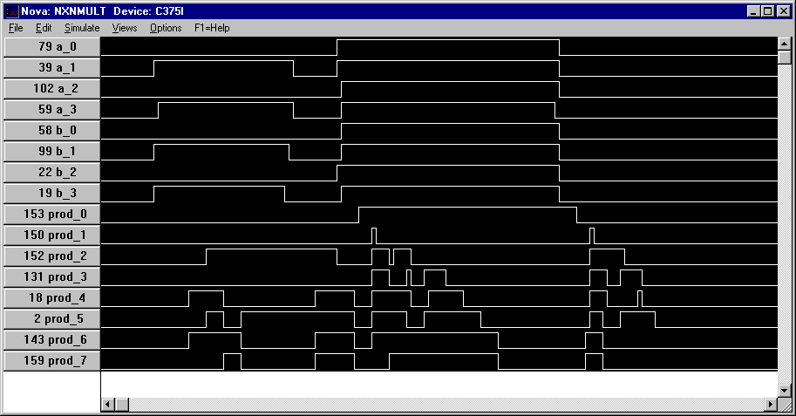
-6 x –6 = 36
-1 x –1 = 1

Several more multiplications are simulated below:
3 (0011) x –7 (1001) = -21 (11101011)
-7 x 3 = -21 (the commutation of the above)
7 (0111) x 7 (0111) = 49 (00110001).

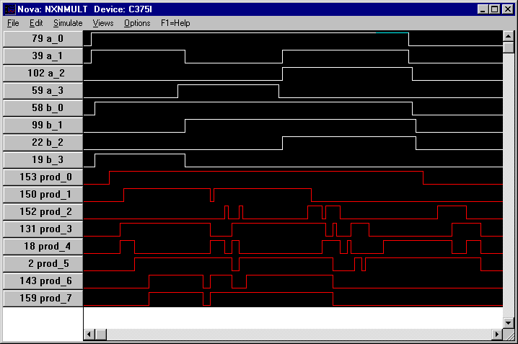
-7 x 3 = -21
3 x –7 = -21
7 x 7 = 49

